Horizon-Internet

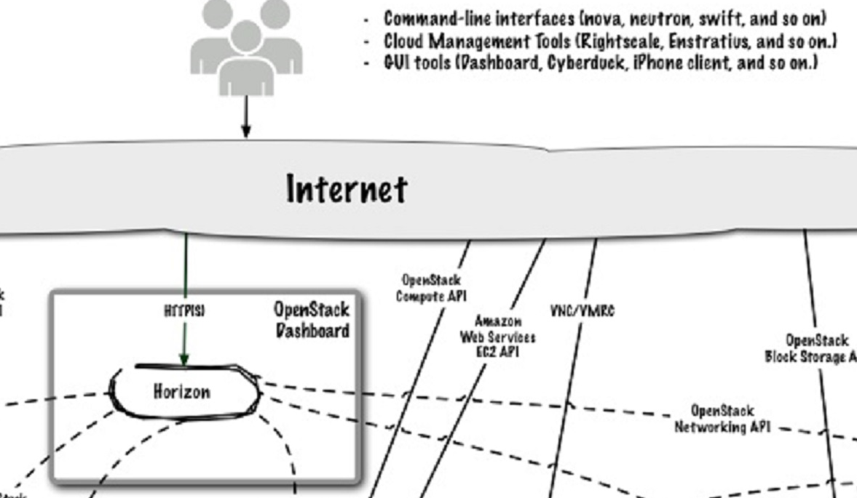Needs:

Manage from a single control pain (multiple clouds)

Keystone / AD integration?

VM restart on host failure

<https://www.youtube.com/watch?v=Yev6IU9EItM>

<https://www.openstack.org/summit/openstack-summit-atlanta-2014/session-videos/presentation/integrating-openstack-with-active-directory-because-ad-ldap>